Overview

Overview of this installation and User guide :

- Chapter 1: Installation of Accuware QuickBooks label connector and components
- Chapter 2: Running the application for the first time/ Configuration
- Chapter 3: Using the Label Connector Designer, designing your first Template

Chapter 1:
Installation of Label Connector for QuickBooks

1.) ( download it here: )

https://accuware-inc.com/support-2018/

Select this button on the download page (14 day trial)
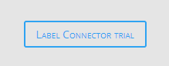

http://myproactivesoftware.com/QBLC/QBLC_Installation.exe

2.) Label connector will show the download file in lower left of your computer screen: ( see figure 1 below) . Select small up arrow and select “open”.

Figure 1:

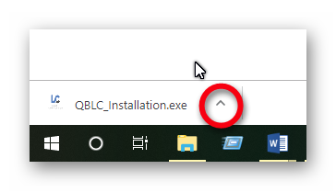

Note: this will download and install 2 applications. You will need to press “Finish” when the first application finishes installing for the second application to be installed.

Note: certain windows protections may prevent executables from installing. Our software has been white listed with Both Microsoft and with several anti virus software packages.
If you do not have enough security rights to install the software you may have to ask your system admin to install the software.

Please follow the next few steps selecting “Next” to allow the install to proceed.

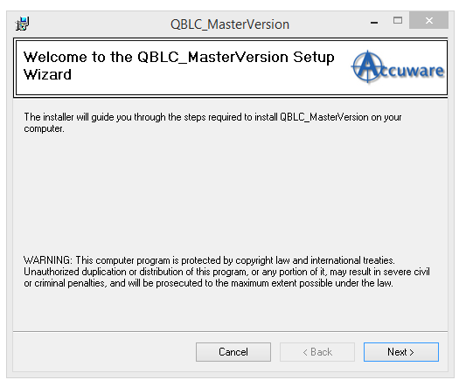

Press Next
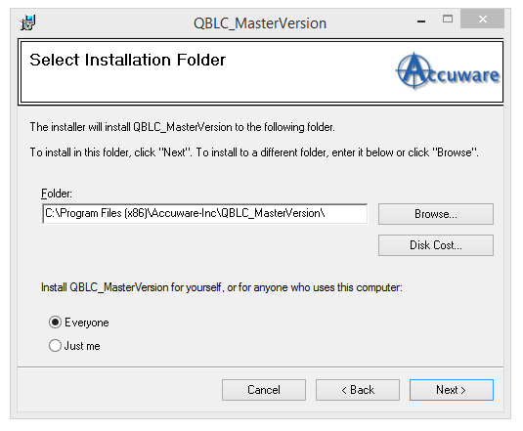
Press Next
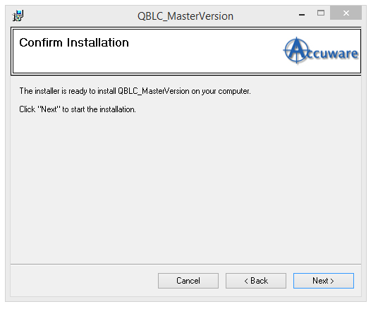
Press Next
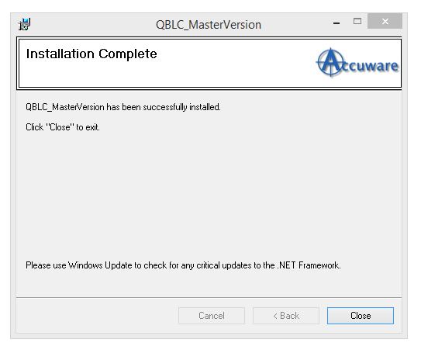

- Click on Close to complete the installation

Chapter 2:
Running the application for the first time/ Configuration

Select the QBLC Icon either from your desktop or from the Recently added section of your programs list.

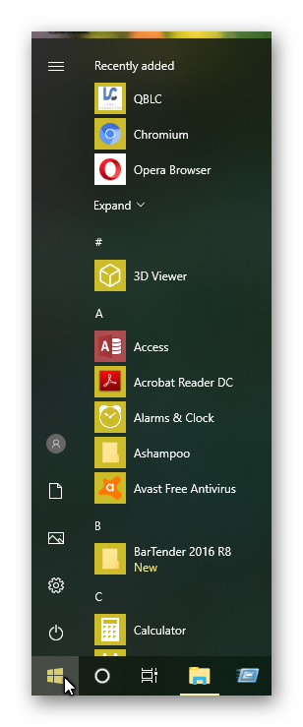

- Settings ( select General Settings)

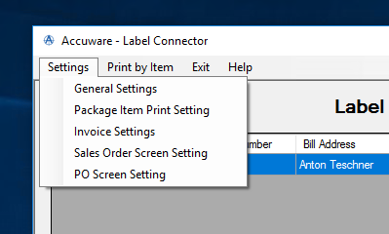

- In the Middle section you can set the default behaviour for the radio buttons. If you will primarily be using a particular transaction type ( PO’s, Sales Orders, Or Invoices) in QuickBooks most of the time than you can set this so that the software automatically opens ready for your most commonly used mode.
- 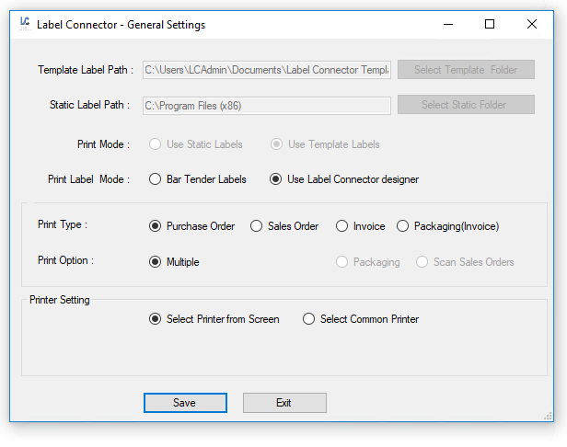

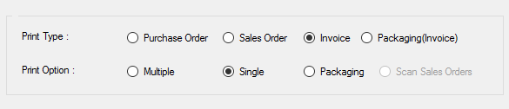

- In the bottom section you can set the printer to be used. (This is optional) . This is useful if you intend to use only one printer to print Labels. If you select “Select Common Printer” the users will not be required to specify the printer to be used while producing Labels. This eliminates an extra step for users. Use of this setting is recommended if you use the “Single printer edition of Bartender Automation edition”. This version of Bartender only allows ONE printer to be used.

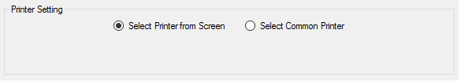

If you use “Select Common Printer” option the printer selected will still appear on the label printing screen but it will be greyed out and will not be required to be selected during printing. (improving efficiency of production of Labels by one step. )
Note: even if “Select Printer from Screen” is used ( default value) our application will always remember the last printer used until the application is closed)

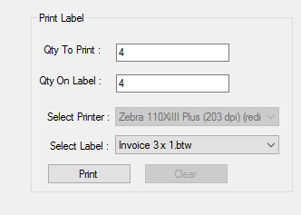

6. Sales Order Settings: if the intent is to use Sales Orders as your main way to search and print , you can enable and configure 2 prompted fields that will deliver data to the label as “entryone” and “entrytwo”.

Sales orders and Invoices also have a feature where you can elect to perform division of the qty of labels to print by enabling a field (and entering the custom item field name) to be used as the divisor amount. So if you have 24 per case and the qty on the sales order is 48 you can elect to have the system only generate 2 labels this way. You would need to populate the QtyPerContainer value inside the items. If you do not supply a value the system will still operate and simply print the quantity of Labels equal to the quantity of labels on the sales order. The user Can use any “name” for this value inside your custom item fields inside QuickBooks as long as you show this same name in box on the setting screen below.
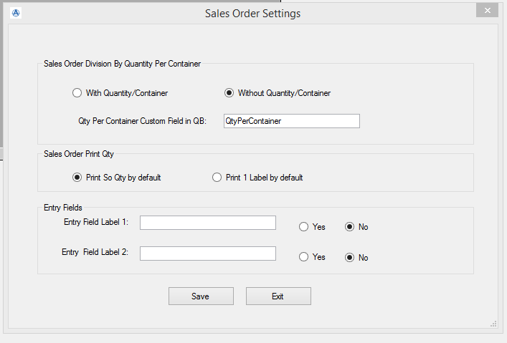

- Querying the QuickBooks data / Orders

- Open Quick books company file which needs to be accessed.

- In Label Connector Enter the Order (PO / SO / Invoice) and click on “Get Order” button.

- For 1st time use QuickBooks requires asks for authentication.

- NOTE***: the below authentication screen will not appear and the system will not connect to the QuickBooks Data unless you are logged into QuickBooks as a QUICKBOOKS ADMIN and ( in single user mode). This is only required the very first time our system connects to the data. After the first established connection to the QuickBooks database , it is no longer required that QuickBooks be logged in as a QuickBooks admin and the below Certificate screen will no longer appear.

- Select “Yes, whenever the Quick Books company file is open” radio button.
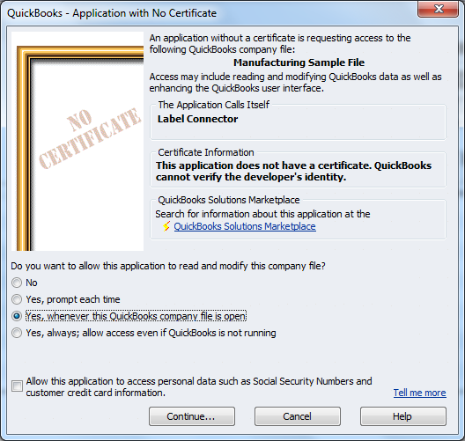

Click on Continue button
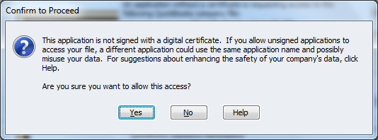

Click on “Yes” button
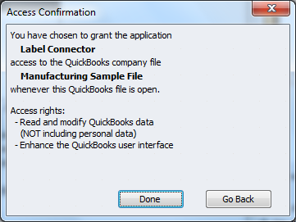

Click on “Done”

NOTE: the company file must be open when the data is accessing from the application for the very first time.

Chapter 4:
Using the Label Connector designer

Please Contact Accuware for help with your Label design. Accuware can send you predesigned Templates for you to import to help expedite your Label design efforts.

Select “Label Design” from main menu

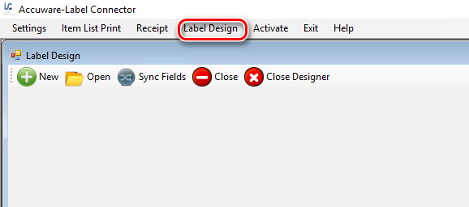

Select “New” to create a new Template

Enter your Template Name ( use a name that describes the template for your own instruction)
Enter the transaction type that you intend to use form QuickBooks. ( choices are Purchase Order, Sales Order, Invoice, or Item List
Enter the dimensions of your Label.
Press Save
NOTE: Width is always the measurement along the edge with the perforation. If your Perf is 4” in length then your width is 4”. ( width is still across the perf even if you print and lay out your Label “sideways” )

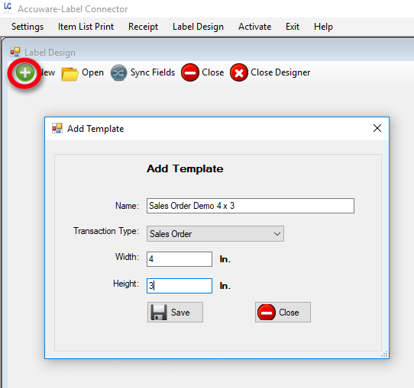

Adding Data Elements to your Label Design

Adding Text Element

Select “Add Text” Tool button

Enter a “Name” for your field. Can be Any Name , for example “Text1” would be easy to remember.

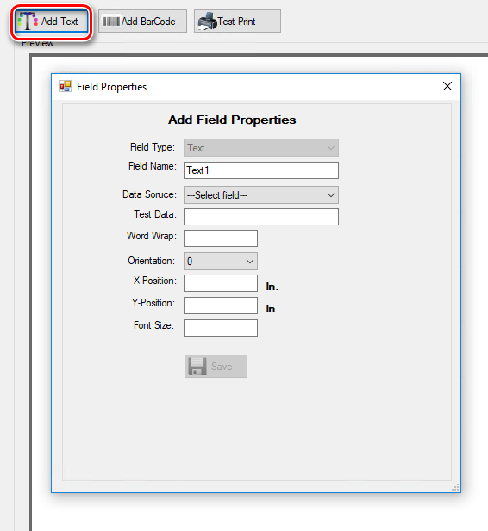

Data Source:
Select the Data Element from QuicKBooks that you wish to print onto the label design.
NOTE: if you wish to add text to your Label that is “Static” ( which means it will not be dynamically populated by the QuickBooks Database) then select “Static” as the Data Source. Examples would be adding your company name , or website to your label. Anything that does not change ever on your labels should use a Static Data Source.

Note: the selections in the drop down will be driven by the “Transaction Type” that you selected earlier when you created the dimensions section of your Template design.

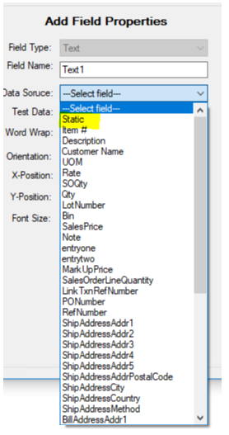

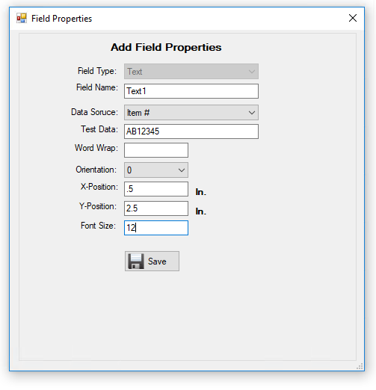

Test data:
Enter some Test Data to aid in your Lay out. This should be typical example data.
Note: It is recommended that you use example Data that will test the maximum length used by the Data element to allow room on your label design.

Word Wrap:

Not required if you do not need to wrap your Data after a certain number of Characters. 99% of the time this field need not be populated unless you are selecting “Description” as your Data Source.

Orientation:

Use Zero degrees if your text should emerge from the printer oriented left to right as the printer dispenses the label.
Use 90 degrees or 270 degrees if you wish for your print to be oriented sideways.

X-Position: ( Horizontal)

From bottom left corner of your design enter the number of inches to the right of the lower left corner for the field to BEGIN at.

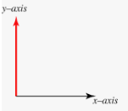

Y-Position: (Vertical)

From bottom left corner of your design enter the number of inches to the above the lower left corner for the field to BEGIN at.

Font Size:

Enter your Font Point Size. Common examples are 10 or 12.

Save:
Save tour Data Field to the Label design.
Your New field should now appear on the Label.

Note: If your field does not appear please adjust your coordinate values. Sometimes it is recommended to try using X=1, Y=1 to understand where the initial field will go.

You can easily edit and adjust your field position by selecting the edit tool from the grid of added fields on the left table. ( Edit tool is the “Pen” shown in the grid.)

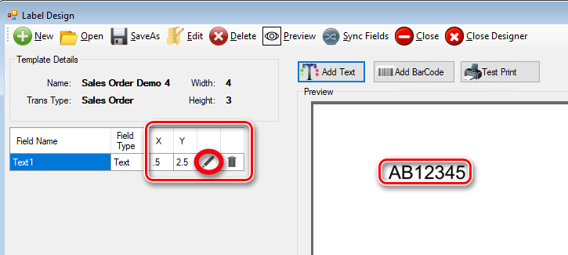

Adding a Barcode Element

Add Barcode:

Double click Ad Barcode Button

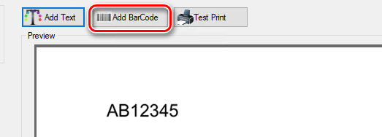

Add Barcode Field Properties window appears.

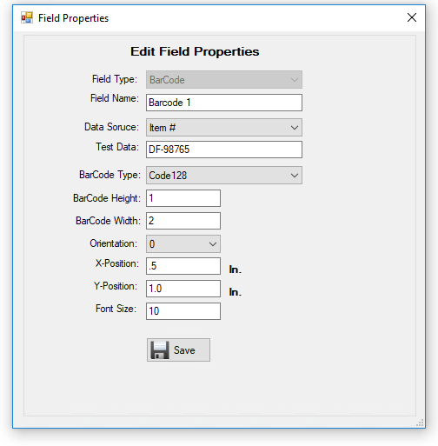

Field name:
Enter a Feld Name that is intuitive. Example Barcode 1.

Data Source:
Select a Data Source to use in QuickBooks. Common selections to use are Item#, Barcode Value, Manufacturers Part Number, or you can use a QuickBooks Item Custom field.

Test data:
Enter some representative example Data to use on the design screen. This is important because the length of your Barcode ( and whether the Barcode will fit onto your Label is in many ways driven by the number of digits in your Barcode. ) Our system can compress the Barcode into an area ( in the settings below) , but if your Part numbers are 15 digits then use 15 digits of example data, to access how compressed the Bars are getting when printed.

Barcode Type:
Choose Code 128, UPC-A, Code 39, or Data Matrix.

Code 128: Most common and has excellent compression, and supports any length , number of digits or character type.

UPC-A: supports 12 digits only. 12th digit must be a valid check digit. Mainly used by Point of Sale Organizations.

Code 39: Support most standard characters, but does not compress as efficiently as code 128.

Data Matrix: 2 dimensional Barcode, can compress large amounts of data into a small area.

X-Position: ( Horizontal)

From bottom left corner of your design enter the number of inches to the right of the lower left corner for the field to BEGIN at.

Y-Position: (Vertical)

From bottom left corner of your design enter the number of inches to the above the lower left corner for the field to BEGIN at.

Font Size:

Enter your Font Point Size. Common examples are 10 or 12.
Save:
Save tour Data Field to the Label design.
Your New field should now appear on the Label.

Note: If your field does not appear please adjust your coordinate values. Sometimes it is recommended to try using X=1, Y=1 to understand where the initial field will go.

You can easily edit and adjust your Barcode position by selecting the edit tool from the grid of added fields on the left table. ( Edit tool is the “Pen” shown in the grid.)

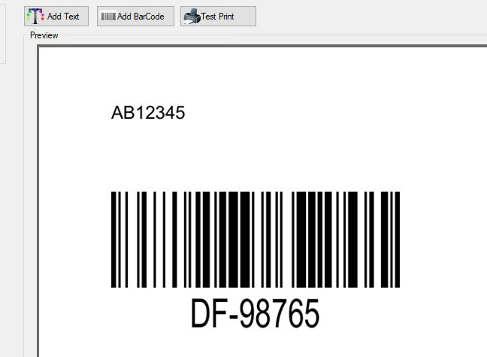

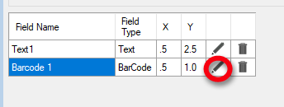

Test Print

Test Print your label from the design screen to refine the field placement to allow your print to be precisely where you require.

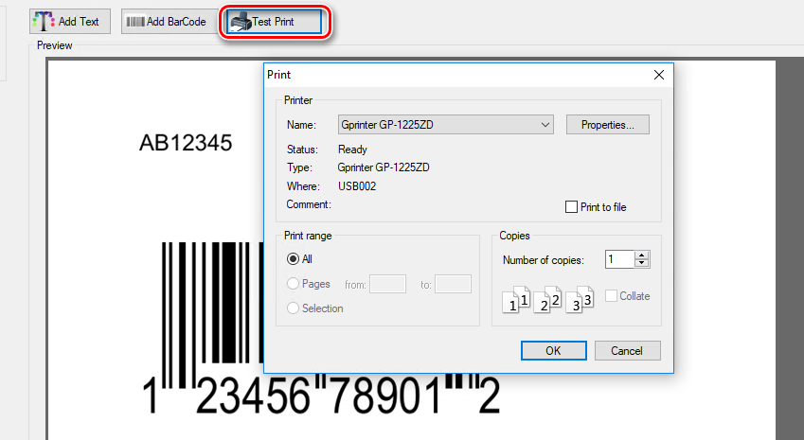

Supported Data Elements

Below is our list of Supported fields for your Labels

QuickBooks Sales Orders

Fields supported

Label | Substring Name (name to be used in Bartender)
Customer Name: Job  If Job selected , it pulls in both. | CustomerRefFullName
PO number | PONumber
Sales Rep | SalesRepRef
UoM | SalesOrderLineUnitOfMeasure
FOB (Can be re-named) | FOB
Item | SalesOrderLineItemRefFullName
Item Description | SalesOrderLineDesc
Manufacturers Part Number | MPN
Barcode Value | BarcodeValue
Line Items QB Lot from Lot tracking in QB | LotNumber
Transaction ID | TxnID
Date | TxnDate
Due Date | DueDate
Ship Date | ShipDate
Other (header) | Other
Reference number | RefNumber
Transaction Line ID (for item in child grid) | SalesOrderLineTxnLineID
Sales Price on Sales Order | SalesOrderLineRate
Sales price after customer multiplier applied | MarkUpPrice
Other1 (Columns) | Other1
Other2 (Columns) | Other2
Bin value from Advanced Inventory Module | Bin
QtyPerContainer calculates the number of Labels to print. SOQty/ContainerQty  Field name set in settings | QtyPerContainer
ContainerQty to use for Box counts ( 1 of N)
Sales Order Line quantity SOQty ( not editable) | SOQty
Qty on label ( changes with edit) | Qty
Note: The values for “Prnt Label Qty” and the “Qty On Label” are editable | Note: The values for “Prnt Label Qty” and the “Qty On Label” are editable
Company Name from Custmer creation screen | CustomerCompanyName
Custom fields created inside Item | Supported. In Bartender use a Data Source name that is the same as the QuickBooks custom field name. Support Video’s discuss this. See working with Bartender section above.
ship address from Sales Order/ Customer creation screen.  Ship Address line 4,5 added 2018 | ShipAddressAddr1  ShipAddressAddr2  ShipAddressAddr3  ShipAddressAddr4  ShipAddressAddr5  ShipAddressCity  ShipAddressState  ShipAddressPostalCode  ShipAddressCountry
From Customer creation screen | Note
Entry Fields: allows for up to 2 prompted fields that can be customized to appear with appropriate prompts | entryone, entrytwo

QuickBooks Invoices

Fields Supported

Label | Substring Name (name to be used in Bartender)
Line Item Values
Invoice Qty | Invoice Quantity
Invoice Quantity “on Label” | InvoiceLineQuantityOnLabel
Other1 | CustomFieldInvoiceLineOther1
Other2 | CustomFieldInvoiceLineOther2
UoM | InvoiceLineUnitOfMeasure
Item | InvoiceLineItemRefFullName
Item Description | InvoiceLineDesc
Invoice line item Price | InvoiceLineRate
Manufacturers Part number from Item | MPN
Lot Number | InvoiceLineLotNumber
Transaction Line ID (for item in child grid) | InvoiceLineTxnLineID
Item Custom Fields. ( see QuickBooks Help on how to create custom fields in your Items. ) | Supported. In Bartender use a Data Source name that is the same as the QuickBooks ITEM custom field name. ( no spaces) Support Video’s discuss this. See working with Bartender section above.
Customer Based Custom Item Fields | Use Name of Field on Label
QtyPerContainer Support | QtyPerContainer
Header data
Preferred Vendor | PrefVendorRefFullName
Transaction ID | TxnID
Header Sales Rep data | SalesRepRef
FOB | FOB
Other ( Header) | Other
Reference number (Invoice #) | RefNumber
Preferred Vendor | PrefVendorRefFullName
Date | TxnDate
Ship Date | ShipDate
So Number: | LinkTxnRefNumber
P.O. Number | PONumber
Ship Via | ShipAddressMethod
Address -1 | BillAddressAddr1
Also supported from Invoice printing: ship address from invoice | ShipAddressAddr1  ShipAddressAddr2  ShipAddressAddr3  ShipAddressAddr4  ShipAddressAddr5  ShipAddressCity  ShipAddressState  ShipAddressPostalCode  ShipAddressCountry

For Invoice Single Mode:

Value from Screen/ QB | Bartender field Name
Qty On Label Input Box | InvoiceLineQuantity
Invoice Line Quantity | InvoiceQuantity

QuickBooks Purchase Orders

Printing Labels using Purchase Orders Screen from QuickBooks

Label | Substring Name (name to be used in Bartender)
Customer Name | PurchaseOrderCustomer
Customer Job | CustomerJob
Vendor name | VendorRefFullName
Footer Memo Field | Memo
Other1 from PO header | Other1H
PO Item Qty | PurchaseOrderLineQuantity
PO Item UoM | PurchaseOrderLineUnitOfMeasure
PO Item | PurchaseOrderLineItemRefFullName
Other1 from Columns | Other1L
Other2 from Columns | Other2L
SubItemOf | SubItemOf
Item description | PurchaseOrderLineDesc
Manufacturers Part Number from Item Screen | MPN
Transaction ID | TxnID
Date | TxnDate
Reference number | RefNumber
Transaction Line ID (for item in child grid) | PurchaseOrderLineTxnLineID
Barcode Number | BarCodeValue
Sales Description | SalesDesc
Sales Price in Item | SalesPrice
Entry1 | Entry1 ( used in receipts Mode Only)
Entry2 | Entry2 ( used in receipts Mode Only)
Item custom fields by any name (2017) | Use the item custom field Name without spaces.
QtyPerContainer Support | Enter Values into settings
Editing of Qty to Print and Qty on Label
Quantity On Label ( and edited Qty on Label from Grid) | Qty

Receipts Without Bill

Site | Site
Bin | Bin
QtyData ( for the receipt) | RecQty
Description | PurchaseOrderLineDesc
PO Number | RefNumber
Lot Number | LotNo
Item Name | PurchaseOrderLineItemRefFullName
Barcode Number | BarCodeValue
SubItemOf | SubItemOf
Sell Price | SalesPrice
Item Custom Fields | Use Custom Field Name
Entry1 | Entry1
Entry2 | Entry2
Serial Numbers entered into Receipts | ReceiptSerialNumber
Item Custom Fields | In Bartender , Use Name created in the item without spaces. (spaces are ok in QuickBooks Custom Item Fields.)

Packaging Option for Sales Order

Packaging Option for Sales Order

CO-69

Header
PONumber | PONumber
Sales Order Number | RefNumber
Customer Name | CustomerRefFullName
ShipDate | ShipDate
Line Items
Line item Qty (editable) | SOQty<1-X>
Sales Order item | SalesOrderLineItemRefFullName<1 to X>
Sales Order Line Description | SalesOrderLineDesc<1 to X>
Unit of Measure | SalesOrderLineUOM<1 to X>
Item Custom Fields | Use Item Custom Field Name with 1,2,3,4 appended.
Other1 | Other1X ( from line items)
Sales Order Date | TxnDate
11/7/18 | ShipAddressAddr1  ShipAddressAddr2  ShipAddressCity  ShipAddressPostalCode  ShipAddressState
Item total | TotalQtyPerItem
Other1 Total | TotalWeightPerItem
Other1 | Other1T1 to x

Print By Item Mode ( grid mode and single mode)
Used for: Useful for printing Labels for existing Inventory items. If you have stock already on the shelves and want to get it Labelled this works well. This screen can take a couple minutes to index your items into a local XML file.

Item description | Description
QB Item Name | Itemname
Bar Code Value | barcodevalue
Manufacturers Part Number | mpn
Preferred vendor from Item def. | PrefVendorRef
Qty On Label on Form | qtyonlabel
Item based Custom fields | Use Item Custom field Name.
Average Cost | AverageCost
SalesPrice | SalesPrice
Entry field ( can be any) | LotNo
 | Support for group, assembly ,Inventory, non inventory type items. For Group items only Item Name and Description will print since they are the only fields supported by QB.

For Packaging Option: For Invoice
.
InvoiceLineItemRefFullName1-x
InvoiceLineDesc1-X
InvoiceLineRate1-x
InvoiceLineAmount1-x
Other1-X
BillAddressAddr1
BillAddressAddr2
BillAddress
ShipAddressAddr1
ShipAddressAddr2
ShipAddress

InvoiceLineQuantity1-X
RefNumber
PONumber
SalesTaxTotal
BalanceRemaining
TxnDate
ShipDate

Appendix I

User Guide:

Packaging Mode example:

Packaging mode allows users to query invoices and print multiple line items to a label or toa packing slip/ Pick List. Example of a print out is below.

Query for Invoice number 8093 pulls up the items on the invoice
User selects which Items ( select up to 6) to be placed on the first Case Label. ( or packing slip)

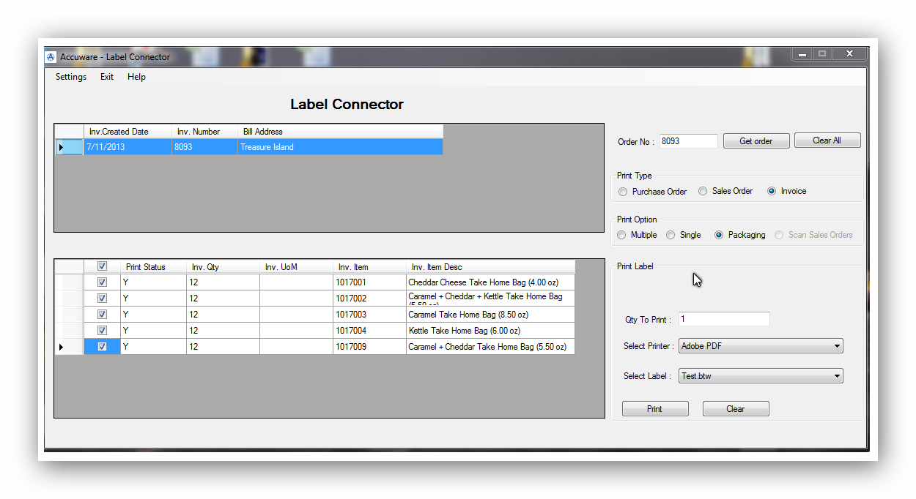

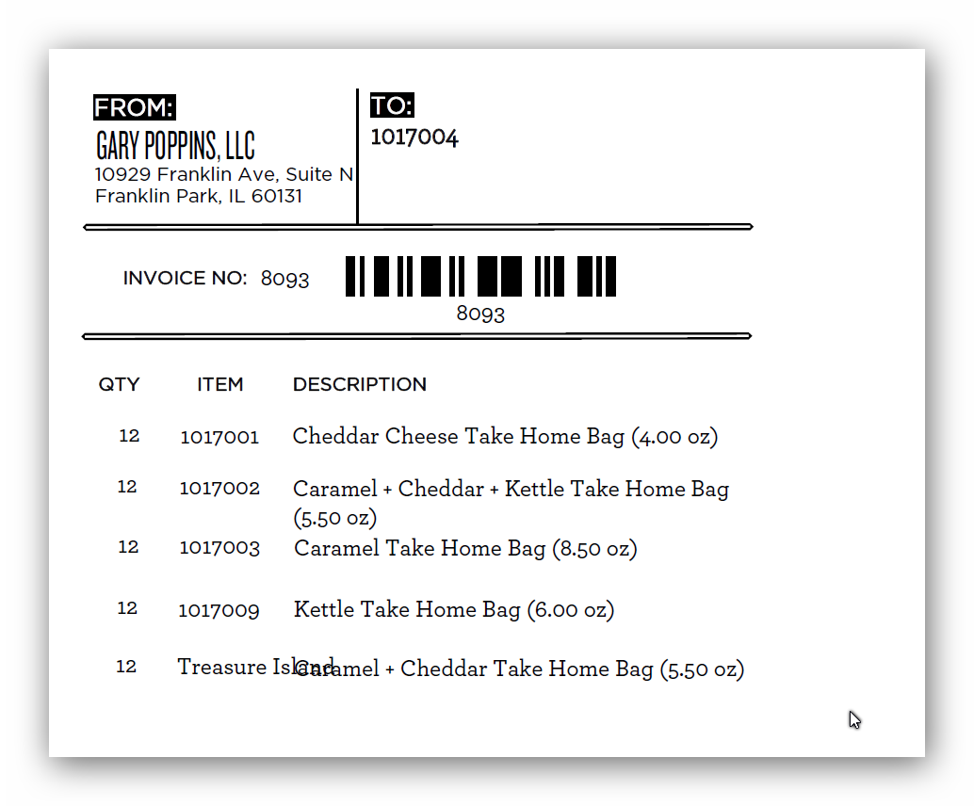

Example of the related invoice to the screens above is shown below:

Support:

Quick Links

List of Supported Fields

Sales Orders (link)
Invoices (link)
Purchase Orders (Link)

Useful Content

- Help: There is a complete Playlist of instructional Video’s on our You Tube Channel located here:
https://www.youtube.com/playlist?list=PL1nGFIzRliaelhIQBb7Yhff4seiC5I4eU

( If you encounter difficulties and Accuware personnel are not available at the time you call you can also call Seagull Scientific support at 425-641-1408. This is for help with installation of Bartender, Seagull License server or printer drivers from Seagull. )

Scroll down on the page at the link to see the phone numbers:

http://www.seagullscientific.com/about-us/contact-us/

Here are some tips to get you started:
- Review the installation instructions in the Getting Started Manual, which is available in more than 20 languages: https://www.seagullscientific.com/downloads/manuals/
- Always install and activate on the computer hosting the License Server first. Other BarTender installations can then automatically pull their activations from the License Server.
- Learn from our experts: Take advantage of our comprehensive online support resources (https://support.seagullscientific.com/hc/en-us), including easy guides to help you:
  - Install Bartender
  - Create and design documents

