**Overview**

**Overview of this installation and User guide :**

* **Chapter 1: Installation of Bartender**
* **Chapter 2: Installation of Accuware QuickBooks label connector and components**
* **Chapter 3: Running the application for the first time/ Configuration**
* **Chapter 4: Creating Bartender Labels to work with the Quick Books Label Connector.**

**Chapter 1:**

1. **Bartender Install ( if you already have Bartender installed please proceed to Chapter 2.)**
2. **Download Bartender Label software here: ( 64 or 32 bit versions)**

[**https://www.seagullscientific.com/downloads/**](https://www.seagullscientific.com/downloads/).

1. Step by step walk through on how to install Bartender here: <https://support.seagullscientific.com/hc/en-us/articles/206574638-Installing-BarTender#ainstall>
2. Required Components. When installing we recommend that you elect to specify installation components. Label Connector only requires Bartender designer, License server, and the .NET SDK. ( see figure 1 below)
3. Note: If you are evaluating Bartender ONLY please go to Help menu and select “Edition selection” and simulate Automation edition. Automation edition features are needed in order for the Label connector to control Bartender in the background. ( see figure 2 below)

**Figure 1:**

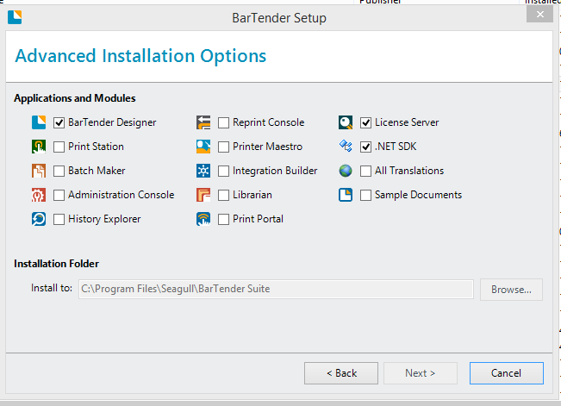

Figure 2 :

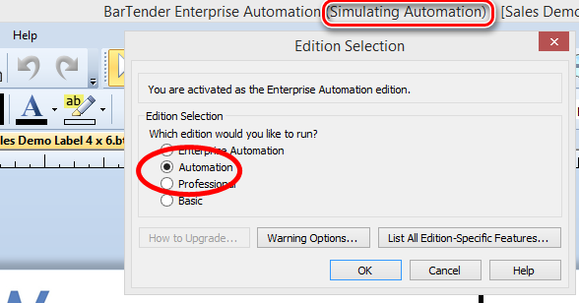

1. **Printer driver installation**

**Using a thermal printer?** For best results, rely on the latest Drivers by Seagull™ for superior speed and reliability: <https://www.seagullscientific.com/drivers/>

**Label Connector is compatible with any printer that has a windows driver.** We recommend “Label” type printers as they allow the most control. Commonly used printers are Zebra, Datamax, Dymo, and Brother. As your Label printing needs increase please contact Accuware for recommendations on a Printer.

1. **Test Your Bartender installation**

After bartender is installed and functioning the user should test and successfully open and print a label to their intended printer. The Label to be tested should be the Label that is intended to be used with Accuware Label connector. This label should be saved in a folder that will later need to be referenced in Accuware label connector settings, so that Label connector can find the label. Note: Please download and test one of the sample Label designs provided by Accuware: [www.accuware-inc.com/qblc/Sample Labels 2017.zip](http://www.accuware-inc.com/qblc/Sample%20Labels%202017.zip)

**Chapter 2:**

**Installation of Accuware QuickBooks label connector and components**

* **Installation of Label Connector for QuickBooks ( download it here: )**

[**http://myproactivesoftware.com/QBLC/QBLC_Installation.exe**](http://myproactivesoftware.com/QBLC/QBLC_Installation.exe)

Note: this will download and install 2 applications. You will need to press “Finish” when the first application finishes installing for the second application to be installed.

Note: certain windows protections may prevent executables from installing. Please select “More Info” to install.

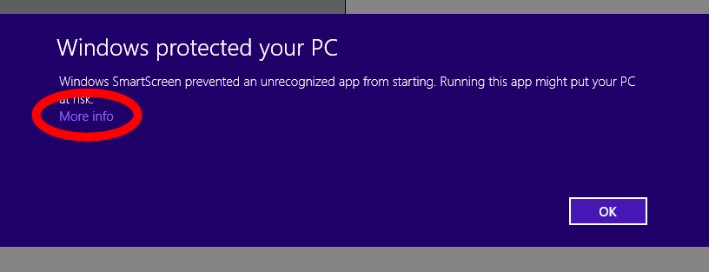

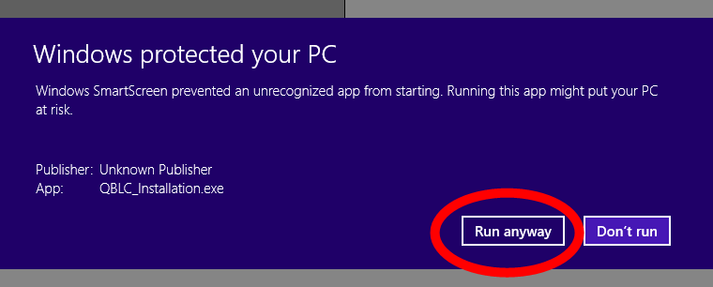

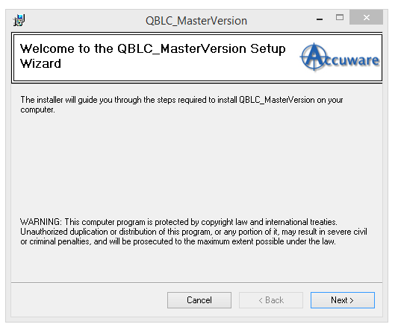

Press Next

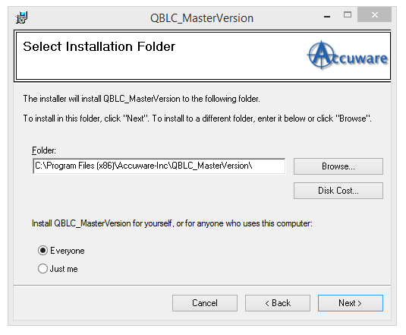

Press Next

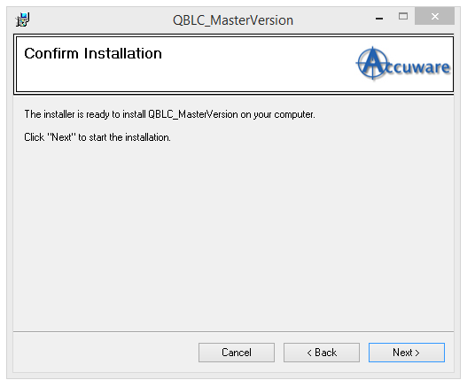

Press Next

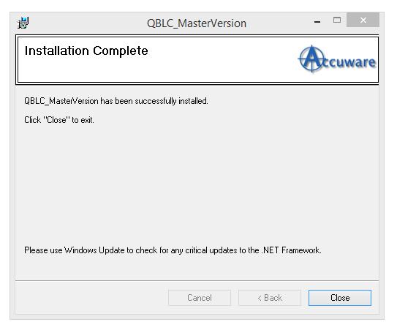

1. Click on Close to complete the installation

Chapter 3:

Running the application for the first time/ Configuration

* Double click on the icon created on the desktop 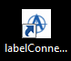
* or Start 🡪 All Programs🡪Accuware🡪Label Connector.

1. Settings
2. General Settings: Inside the software go to “Settings=>General Settings” and browse to the folder on your system where you intend to save the Bartender Label template files. Press ok when done.

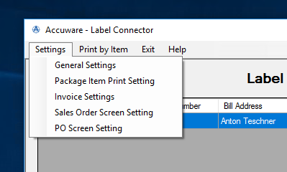

and browse to the folder on your system where you intend to save the Bartender Label template files. ( by pressing “Select Template files Folder” button. ) 99 % of all users will use this feature. It is not usually necessary to also select a folder for “Select Static Folder” button.

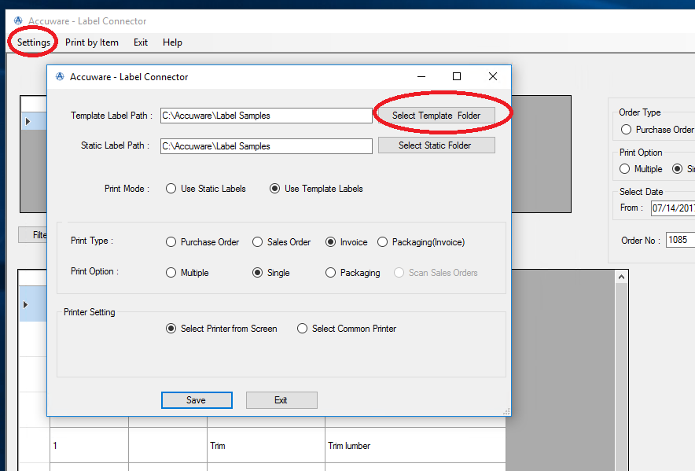

1. To help get started you can download our sample Labels to have some great examples of labels that you can print with the system. Download them here:

[www.accuware-inc.com/qblc/Sample Labels 2017.zip](http://www.accuware-inc.com/qblc/Sample%20Labels%202017.zip). Simply save these files ( after unzipping) into the folder that was just set ( in the previous step) to use them with our product. These files may need to be adjusted in their Label dimensions towork well with your particular label stock.

1. In the Middle section you can set the default behaviour for the radio buttons. If you will primarily be using a particular transaction type ( PO’s, Sales Orders, Or Invoices) in QuickBooks most of the time than you can set this so that the software automatically opens ready for your most commonly used mode.

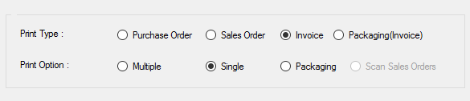

1. In the bottom section you can set the printer to be used. (This is optional) . This is useful if you intend to use only one printer to print Labels. If you select “Select Common Printer” the users will not be required to specify the printer to be used while producing Labels. This eliminates an extra step for users. Use of this setting is recommended if you use the “Single printer edition of Bartender Automation edition”. This version of Bartender only allows ONE printer to be used.

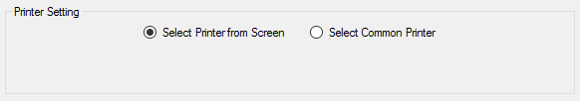

If you use “Select Common Printer” option the printer selected will still appear on the label printing screen but it will be greyed out and will not be required to be selected during printing. (improving efficiency of production of Labels by one step. )

Note: even if “Select Printer from Screen” is used ( default value) our application will always remember the last printer used until the application is closed)

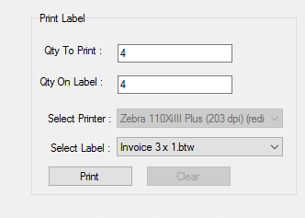

6. Sales Order Settings: if the intent is to use Sales Orders as your main way to search and print , you can enable and configure 2 prompted fields that will deliver data to the label as “entryone” and “entrytwo”.

Sales orders and Invoices also have a feature where you can elect to perform division of the qty of labels to print by enabling a field (and entering the custom item field name) to be used as the divisor amount. So if you have 24 per case and the qty on the sales order is 48 you can elect to have the system only generate 2 labels this way. You would need to populate the QtyPerContainer value inside the items. If you do not supply a value the system will still operate and simply print the quantity of Labels equal to the quantity of labels on the sales order. The user Can use any “name” for this value inside your custom item fields inside QuickBooks as long as you show this same name in box on the setting screen below.

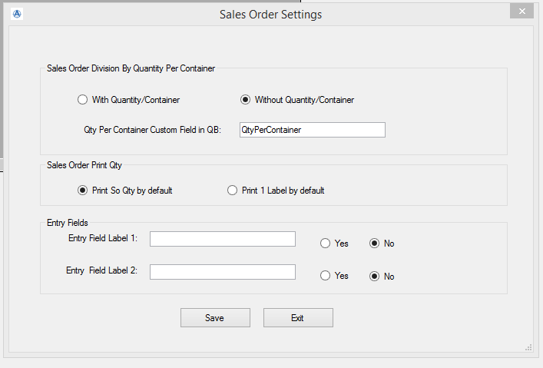

1. Querying the QuickBooks data / Orders
2. Open Quick books company file which needs to be accessed.
3. In Label Connector Enter the Order (PO / SO / Invoice) and click on “Get Order” button.
4. For 1st time use QuickBooks requires asks for authentication.
5. **NOTE***: the below authentication screen will not appear and the system will not connect to the QuickBooks Data unless you are logged into QuickBooks as a QUICKBOOKS ADMIN ( in single user mode).** This is only required the very first time our system connects to the data. After the first established connection to the QuickBooks database , it is no longer required that QuickBooks be logged in as a QuickBooks admin and the below Certificate screen will no longer appear.
6. Select “Yes, whenever the Quick Books company file is open” radio button.

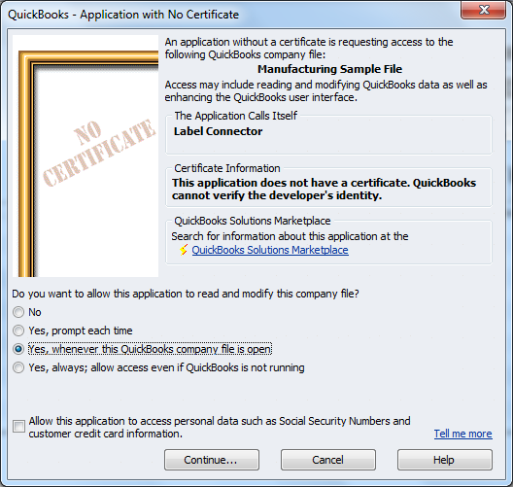

Click on Continue button

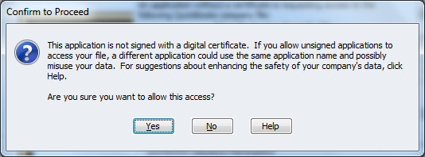

Click on “Yes” button

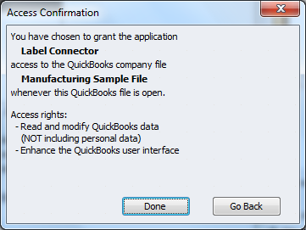

Click on “Done”

**NOTE: the company file must be open when the data is accessing from the application for the very first time.**

**Chapter 4:**

**Creating Bartender Labels to work with the Quick Books Label Connector.**

**Working with Bartender:**

1. Ask your Accuware representative for sample labels to work with the application as a partial guide on how to properly create Bartender label designs. You can also download the Bartender Sample Labels ,at the link below, to use as examples. These labels already have Data Source Names properly configured to link to our software.

[www.accuware-inc.com/qblc/Sample Labels 2017.zip](http://www.accuware-inc.com/qblc/Sample%20Labels%202017.zip)

1. Opening one of the sample Label (.btw) files, click on one of the dynamic fields on the label design. ( shown below with handles)
2. ****It is always recommended that you print your intended label from Bartender directly and then re-save the label. This associates the label with your printer for better response , allows examination of the real printed output, verifies that the Bartender License Server is issuing licenses correctly, and verifies printer driver, cable functionality.

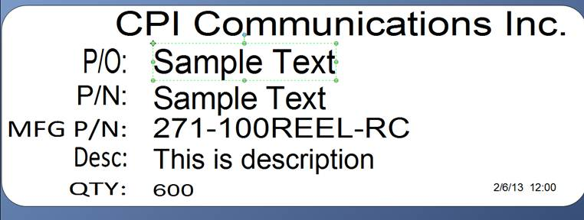

1. In the data sources tree on the left panel you can see the field that you have selected. In the right hand Panel select the Data Source tab. Inside the “name” box you will need to enter a value from the list of supported fields in Quick Books.

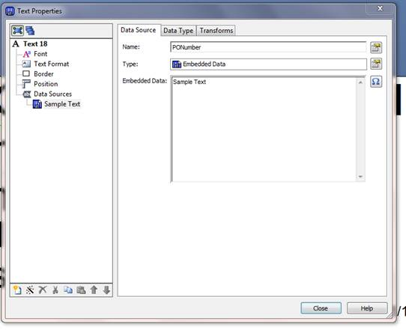

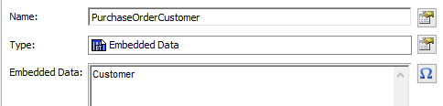

Below is the current list of supported Quick Books fields that can be referenced on a Label. Others can be added upon request.

**See this video on where to place the below field names to connect your Label field to Label Connector Program:**

[**https://youtu.be/du8lsj6S0vw?list=PL1nGFIzRliaelhIQBb7Yhff4seiC5I4eU**](https://youtu.be/du8lsj6S0vw?list=PL1nGFIzRliaelhIQBb7Yhff4seiC5I4eU)

**QuickBooks Sales Orders**

**Fields supported**

Current version will support following fields for SO + custom fields from Item definition in Label Printing

|  |  |
| --- | --- |
| **Label** | **Substring Name (name to be used in Bartender)** |
| Customer Name: Job  If Job selected , it pulls in both. | CustomerRefFullName |
| PO number | PONumber |
| Sales Rep | SalesRepRef |
| UoM | SalesOrderLineUnitOfMeasure |
| FOB (Can be re-named) | FOB |
| Item | SalesOrderLineItemRefFullName |
| Item Description | SalesOrderLineDesc |
| Manufacturers Part Number | MPN |
| Barcode Value | BarcodeValue |
| Line Items QB Lot from Lot tracking in QB | LotNumber |
| Transaction ID | TxnID |
| Date | TxnDate |
| Due Date | DueDate |
| Ship Date | ShipDate |
| Other (header) | Other |
| Reference number | RefNumber |
| Transaction Line ID (for item in child grid) | SalesOrderLineTxnLineID |
| Sales Price on Sales Order | SalesOrderLineRate |
| Sales price after customer multiplier applied | MarkUpPrice |
| Other1 (Columns) | Other1 |
| Other2 (Columns) | Other2 |
| Bin value from Advanced Inventory Module | Bin |
| QtyPerContainer calculates the number of Labels to print. SOQty/ContainerQty  Field name set in settings | QtyPerContainer |
| ContainerQty to use for Box counts ( 1 of N) |  |
| Sales Order Line quantity SOQty ( not editable) | SOQty |
| Qty on label ( changes with edit) | Qty |
| Note: The values for “Prnt Label Qty” and the “Qty On Label” are editable | Note: The values for “Prnt Label Qty” and the “Qty On Label” are editable |
|  |  |
| Company Name from Custmer creation screen | CustomerCompanyName |
| Custom fields created inside Item | Supported. In Bartender use a Data Source name that is the same as the QuickBooks custom field name. Support Video’s discuss this. See working with Bartender section above. |
| ship address from Sales Order | ShipAddressAddr1              ShipAddressAddr2              ShipAddressAddr3              ShipAddressAddr4              ShipAddressAddr5              ShipAddressCity              ShipAddressState              ShipAddressPostalCode              ShipAddressCountry |
| Entry Fields: allows for up to 2 prompted fields that can be customized to appear with appropriate prompts | entryone, entrytwo |
|  |  |

**QuickBooks Invoices**

Fields Supported

|  |  |
| --- | --- |
| **Label** | **Substring Name (name to be used in Bartender)** |
|  |  |
| **Line Item Values** |  |
| Invoice Qty | Invoice Quantity |
| Invoice Quantity “on Label” | InvoiceLineQuantityOnLabel |
| Other1 | CustomFieldInvoiceLineOther1 |
| Other2 | CustomFieldInvoiceLineOther2 |
| UoM | InvoiceLineUnitOfMeasure |
| Item | InvoiceLineItemRefFullName |
| Item Description | InvoiceLineDesc |
| Manufacturers Part number from Item | MPN |
| Lot Number | InvoiceLineLotNumber |
| Transaction Line ID (for item in child grid) | InvoiceLineTxnLineID |
| Item Custom Fields. ( see QuickBooks Help on how to create custom fields in your Items. ) | Supported. In Bartender use a Data Source name that is the same as the QuickBooks **ITEM** custom field name. ( no spaces) Support Video’s discuss this. **See working with Bartender section above.** |
| Customer Based Custom Item Fields | Use Name of Field on Label |
| QtyPerContainer Support | QtyPerContainer |
| **Header data** |  |
| Preferred Vendor | PrefVendorRefFullName |
| Transaction ID | TxnID |
| Header Sales Rep data | SalesRepRef |
| FOB | FOB |
| Reference number (Invoice #) | RefNumber |
| Preferred Vendor | PrefVendorRefFullName |
| Date | TxnDate |
| Ship Date | ShipDate |
| So Number: | LinkTxnRefNumber |
|  |  |
| P.O. Number | PONumber |
| Ship Via | ShipAddressMethod |
|  |  |
| Address -1 | BillAddressAddr1 |
| Also supported from Invoice printing:  ship address from invoice | ShipAddressAddr1              ShipAddressAddr2              ShipAddressAddr3              ShipAddressAddr4              ShipAddressAddr5              ShipAddressCity              ShipAddressState              ShipAddressPostalCode              ShipAddressCountry |
|  |  |

For Invoice Single Mode:

|  |  |
| --- | --- |
| **Value from Screen/ QB** | **Bartender field Name** |
| **Qty On Label Input Box** | **InvoiceLineQuantity** |
| **Invoice Line Quantity** | **InvoiceQuantity** |
|  |  |
|  |  |
|  |  |

**QuickBooks Purchase Orders**

Printing Labels using Purchase Orders Screen from QuickBooks

|  |  |
| --- | --- |
| **Label** | **Substring Name (name to be used in Bartender)** |
| **Customer Name** | **PurchaseOrderCustomer** |
| **Customer Job** | **CustomerJob** |
| Vendor name | **VendorRefFullName** |
| Footer Memo Field | **Memo** |
| Other1 from PO header | **Other1H** |
| PO Item Qty | **PurchaseOrderLineQuantity** |
| PO Item UoM | **PurchaseOrderLineUnitOfMeasure** |
| PO Item | **PurchaseOrderLineItemRefFullName** |
| Other1 from Columns | **Other1L** |
| Other2 from Columns | **Other2L** |
| SubItemOf | **SubItemOf** |
| Item description | **PurchaseOrderLineDesc** |
| Manufacturers Part Number from Item Screen | **MPN** |
| Transaction ID | **TxnID** |
| Date | **TxnDate** |
| Reference number | **RefNumber** |
| Transaction Line ID (for item in child grid) | **PurchaseOrderLineTxnLineID** |
| Barcode Number | **BarCodeValue** |
| Sales Description | **SalesDesc** |
| Sales Price in Item | **SalesPrice** |
| Entry1 | **Entry1** |
| Entry2 | **Entry2** |
| Item custom fields by any name (2017) | **Use the item custom field Name without spaces.** |
| QtyPerContainer Support | **QtyPerContainer** |
| Editing of Qty to Print and Qty on Label |  |
| Quantity On Label ( and edited Qty on Label from Grid) | **Qty** |

**Receipts Without Bill**

|  |  |
| --- | --- |
| **Site** | **Site** |
| **Bin** | **Bin** |
| **QtyData ( for the receipt)** | **RecQty** |
| **Description** | **PurchaseOrderLineDesc** |
| **PO Number** | **RefNumber** |
| **Lot Number** | **LotNo** |
| **Item Name** | **PurchaseOrderLineItemRefFullName** |
| **Barcode Number** | **BarCodeValue** |
| **SubItemOf** | **SubItemOf** |
| **Sell Price** | **SalesPrice** |
| **Item Custom Fields** | **Use Custom Field Name** |
| **Entry1** | **Entry1** |
| **Entry2** | **Entry2** |
| **Serial Numbers entered into Receipts** | **ReceiptSerialNumber** |
|  |  |
| **Item Custom Fields** | **In Bartender , Use Name created in the item without spaces. (spaces are ok in QuickBooks Custom Item Fields.)** |

**Packaging Option for Sales Order**

**Packaging Option for Sales Order**

**CO-69**

|  |  |
| --- | --- |
| **Header** |  |
| **PONumber** | **PONumber** |
| **Sales Order Number** | **RefNumber** |
| **Customer Name** | **CustomerRefFullName** |
| **ShipDate** | **ShipDate** |
|  |  |
| **Line Items** |  |
| **Line item Qty (editable)** | **SOQty<1-X>** |
| **Sales Order item** | **SalesOrderLineItemRefFullName<1 to X>** |
|  |  |
| **Sales Order Line Description** | **SalesOrderLineDesc<1 to X>** |
| **Unit of Measure** | **SalesOrderLineUOM<1 to X>** |
| **Item Custom Fields** | **Use Item Custom Field Name with 1,2,3,4 appended.** |
|  |  |
| **Other1** | **Other1X ( from line items)** |
|  |  |
|  |  |
|  |  |
| Sales Order Date | TxnDate |

**Print By Item Mode ( grid mode and single mode)**

**Used for: Useful for printing Labels for existing Inventory items. If you have stock already on the shelves and want to get it Labelled this works well. This screen can take a couple minutes to index your items into a local XML file.**

|  |  |
| --- | --- |
| **Item description** | **Description** |
| **QB Item Name** | **Itemname** |
| **Bar Code Value** | **barcodevalue** |
| **Manufacturers Part Number** | **mpn** |
| **Preferred vendor from Item def.** | **PrefVendorRef** |
| **Qty On Label on Form** | **qtyonlabel** |
| **Item based Custom fields** | **Use Item Custom field Name.** |
| **Average Cost** | **AverageCost** |
| **SalesPrice** | **SalesPrice** |
| **Entry field ( can be any)** | **LotNo** |
|  |  |
|  | **Support for group, assembly ,Inventory, non inventory type items. For Group items only Item Name and Description will print since they are the only fields supported by QB.** |

**For Packaging Option:** For Invoice

.

InvoiceLineItemRefFullName1-x

InvoiceLineDesc1-X

InvoiceLineRate1-x

InvoiceLineAmount1-x

Other1-X

BillAddressAddr1

BillAddressAddr2

BillAddress

ShipAddressAddr1

ShipAddressAddr2

ShipAddress

InvoiceLineQuantity1-X

RefNumber

PONumber

SalesTaxTotal

BalanceRemaining

TxnDate

ShipDate

Appendix I

User Guide:

Packaging Mode example:

Packaging mode allows users to query invoices and print multiple line items to a label or toa packing slip/ Pick List. Example of a print out is below.

Query for Invoice number 8093 pulls up the items on the invoice

User selects which Items ( select up to 6) to be placed on the first Case Label. ( or packing slip)

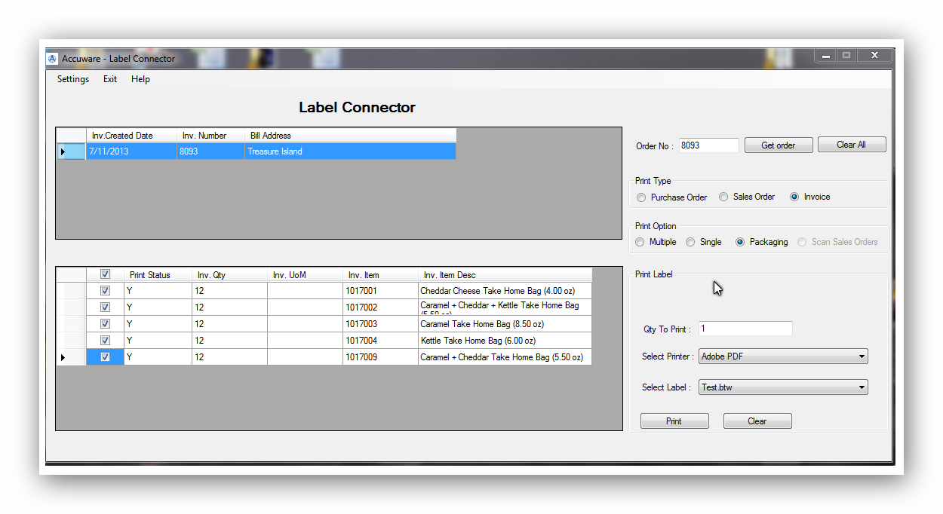

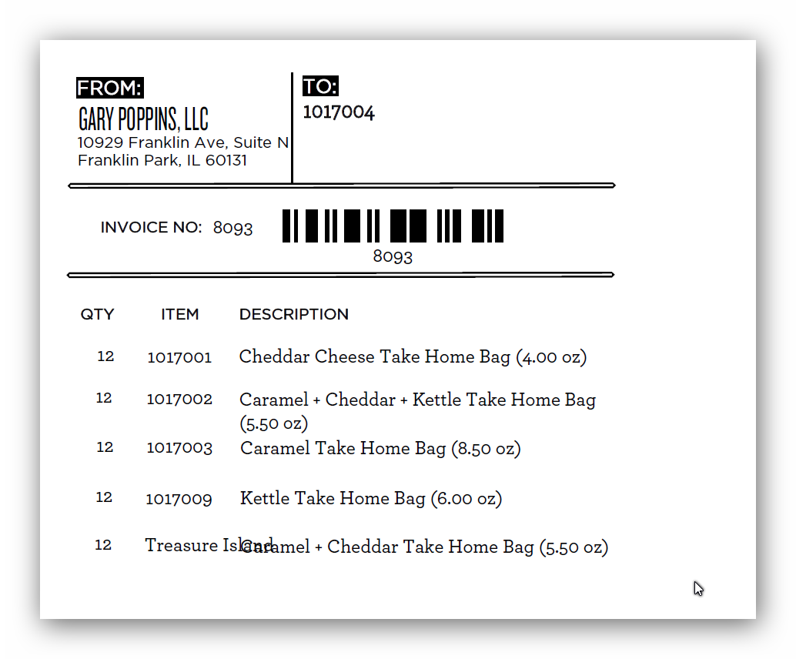

Example of the related invoice to the screens above is shown below:

**Support:**

**Quick Links**

**List of Supported Fields**

**Sales Orders (link)**

**Invoices (link)**

**Purchase Orders (Link)**

**Useful Content**

1. **Help:** There is a complete Playlist of instructional Video’s on our You Tube Channel located here:

<https://www.youtube.com/playlist?list=PL1nGFIzRliaelhIQBb7Yhff4seiC5I4eU>

( If you encounter difficulties and Accuware personnel are not available at the time you call you can also call Seagull Scientific support at 425-641-1408. This is for help with installation of Bartender, Seagull License server or printer drivers from Seagull. )

Scroll down on the page at the link to see the phone numbers:

<http://www.seagullscientific.com/about-us/contact-us/>

**Here are some tips to get you started:**

* **Review the installation instructions in the Getting Started Manual, which is available in more than 20 languages:** <https://www.seagullscientific.com/downloads/manuals/>
* **Always install and activate on the computer hosting the License Server first. Other BarTender installations can then automatically pull their activations from the License Server.**
* **Learn from our experts: Take advantage of our comprehensive online support resources (**<https://support.seagullscientific.com/hc/en-us>**), including easy guides to help you:** 
  + **Install Bartender**
  + **Create and design documents**